HDFS读写数据流分析
【实验名称】
HDFS读写数据流分析
【实验目的】
通过这个实验,学会通过java客户端通过API对HDFS读取数据流程.
【实验要求】
要求实验结束时，每位学生均已搭建HDFS开发环境；编写HDFS读写代码，并在机子上执行了该读写程序，了解HDFS读写文件的调用流程，理解HDFS读写文件的原理。
【实验环境】
HDFS的基础架构了解
Java基础知识

【实验步骤】

1.hdfs java客户端操作

1.1 创建java maven 项目
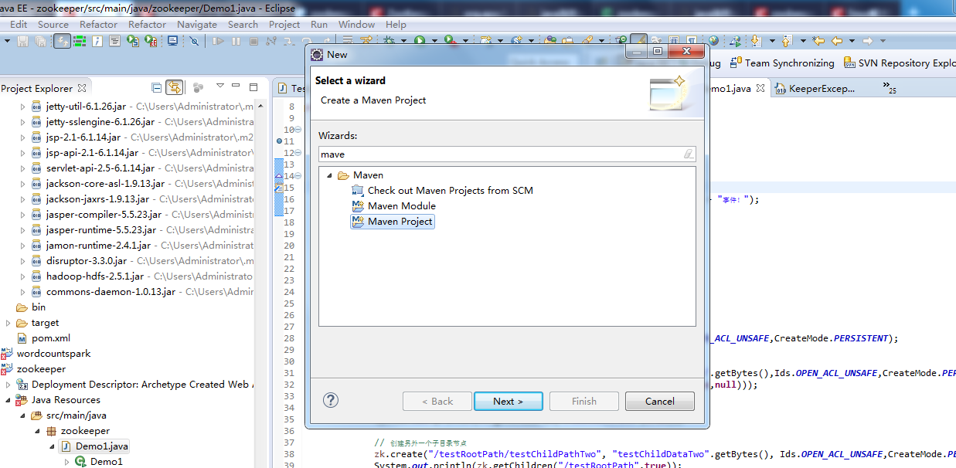

1.2配置pom.xml文件，加载jar包
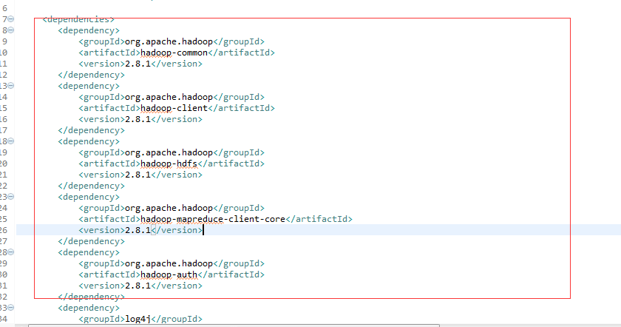

1.3、创建Hdfs连接
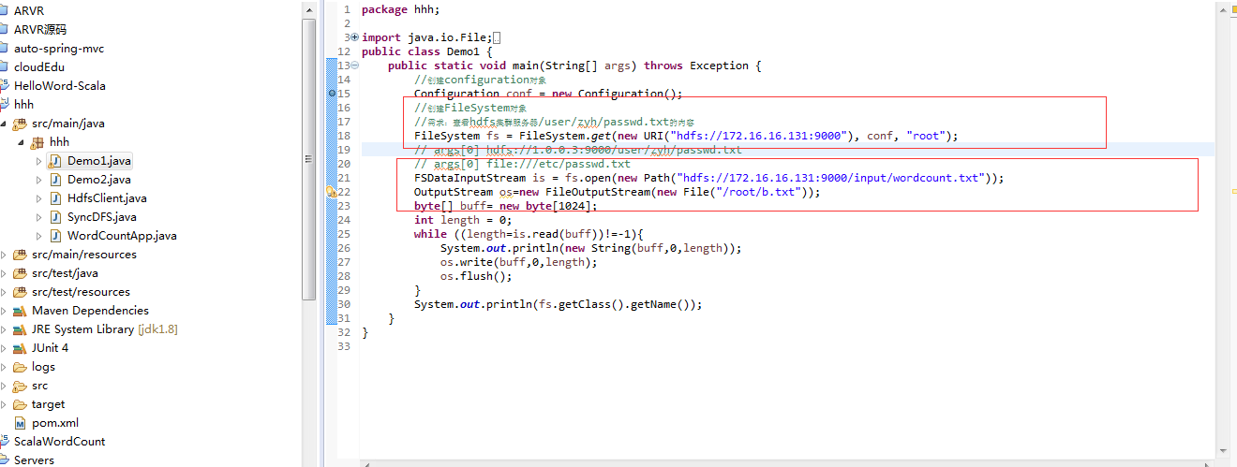

1.4、把hdfs上的文件写到linux目录下
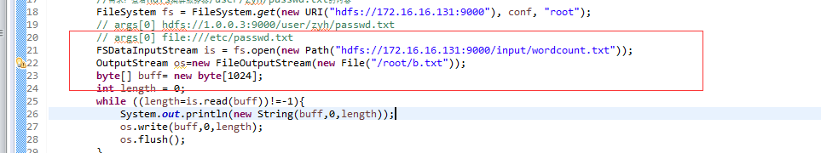

1.5.1、java代码(读取hdfs)
package hhh;

import java.io.File;
import java.io.FileOutputStream;
import java.io.OutputStream;
import java.net.URI;

import org.apache.hadoop.conf.Configuration;
import org.apache.hadoop.fs.FSDataInputStream;
import org.apache.hadoop.fs.FileSystem;
import org.apache.hadoop.fs.Path;
public class Demo1 {
public static void main(String[] args) throws Exception {
//创建configuration对象
Configuration conf = new Configuration();
//创建FileSystem对象
//需求：查看hdfs集群服务器/user/zyh/passwd.txt的内容
FileSystem fs = FileSystem.get(new URI("hdfs://172.16.16.131:9000"), conf, "root");
// args[0] hdfs://1.0.0.3:9000/user/zyh/passwd.txt
// args[0] file:///etc/passwd.txt
FSDataInputStream is = fs.open(new Path("hdfs://172.16.16.131:9000/input/wordcount.txt"));
OutputStream os=new FileOutputStream(new File("/root/b.txt"));
byte[] buff= new byte[1024];
int length = 0;
while ((length=is.read(buff))!=-1){
System.out.println(new String(buff,0,length));
os.write(buff,0,length);
os.flush();
}
System.out.println(fs.getClass().getName());
}
}

1.5.2、java代码(写入hdfs)
package hhh;

import java.io.File;
import java.io.FileInputStream;
import java.net.URI;

import org.apache.commons.io.IOUtils;
import org.apache.hadoop.conf.Configuration;
import org.apache.hadoop.fs.FSDataOutputStream;
import org.apache.hadoop.fs.FileSystem;
import org.apache.hadoop.fs.Path;

public class Demo2 {
public static void main(String[] args) throws Exception {
//创建configuration对象
Configuration conf = new Configuration();
//创建FileSystem对象
//需求：查看hdfs集群服务器/user/zyh/passwd.txt的内容
FileSystem fs = FileSystem.get(new URI("hdfs://172.16.16.131:9000"), conf, "root");
// args[0] hdfs://1.0.0.3:9000/user/zyh/passwd.txt
// args[0] file:///etc/passwd.txt
FileInputStream inputStream = new FileInputStream(new File("/root/b.txt"));
FSDataOutputStream outputStream = fs.create(new Path("/input/test3.txt"),true);
IOUtils.copy(inputStream,outputStream);
}
}

1.6、pom.xml配置文件
<<dependencies>
<dependency>
<groupId>org.apache.hadoop</groupId>
<artifactId>hadoop-common</artifactId>
<version>2.8.1</version>
</dependency>
<dependency>
<groupId>org.apache.hadoop</groupId>
<artifactId>hadoop-client</artifactId>
<version>2.8.1</version>
</dependency>
<dependency>
<groupId>org.apache.hadoop</groupId>
<artifactId>hadoop-hdfs</artifactId>
<version>2.8.1</version>
</dependency>
<dependency>
<groupId>org.apache.hadoop</groupId>
<artifactId>hadoop-mapreduce-client-core</artifactId>
<version>2.8.1</version>
</dependency>
<dependency>
<groupId>org.apache.hadoop</groupId>
<artifactId>hadoop-auth</artifactId>
<version>2.8.1</version>
</dependency>
<dependency>
<groupId>log4j</groupId>
<artifactId>log4j</artifactId>
<version>1.2.17</version>
</dependency>
<dependency>
<groupId>commons-logging</groupId>
<artifactId>commons-logging</artifactId>
<version>1.2</version>
</dependency>
<dependency>
<groupId>com.google.guava</groupId>
<artifactId>guava</artifactId>
<version>19.0</version>
</dependency>
<dependency>
<groupId>commons-collections</groupId>
<artifactId>commons-collections</artifactId>
<version>3.2.2</version>
</dependency>
<dependency>
<groupId>commons-cli</groupId>
<artifactId>commons-cli</artifactId>
<version>1.2</version>
</dependency>
<dependency>
<groupId>commons-lang</groupId>
<artifactId>commons-lang</artifactId>
<version>2.6</version>
</dependency>
<dependency>
<groupId>commons-configuration</groupId>
<artifactId>commons-configuration</artifactId>
<version>1.9</version>
</dependency>
<dependency>
<groupId>org.apache.avro</groupId>
<artifactId>avro</artifactId>
<version>1.7.7</version>
</dependency>
<dependency>
<groupId>commons-io</groupId>
<artifactId>commons-io</artifactId>
<version>2.5</version>
</dependency>
</dependencies>

1.7 把java打包成jar

1.7.1 选中项目右键，选择Export,选中JAR file,然后next下一步

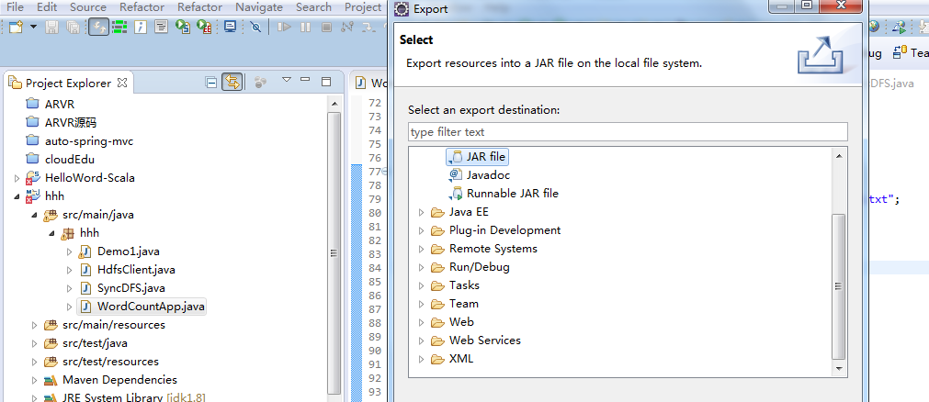

1.7.2选择要打包的项目和地址,然后next下一步

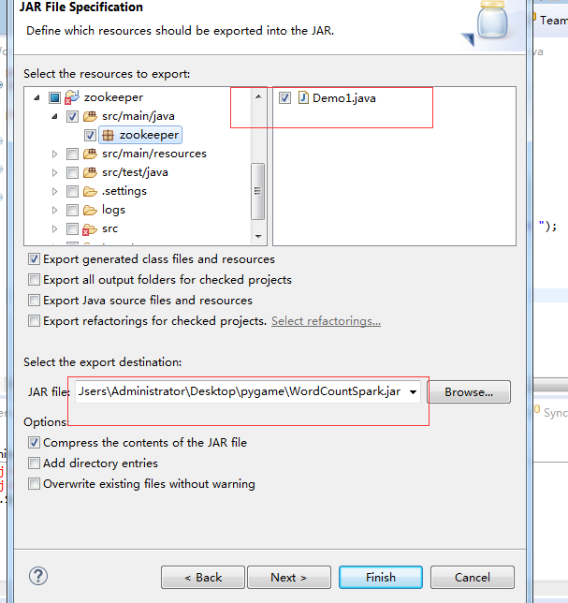

1.7.3 选择打包的class,选择OK 然后Finish
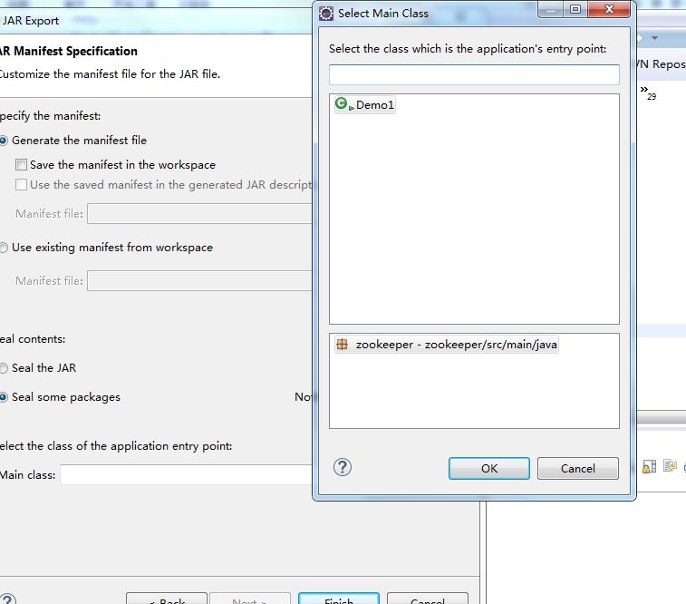

2.Hadoop运行打包好的jar文件

2.1 将打包好的jar上传到linux

2.1.1 右键linux虚拟机，选择Connect SFTP Session 进入sftp
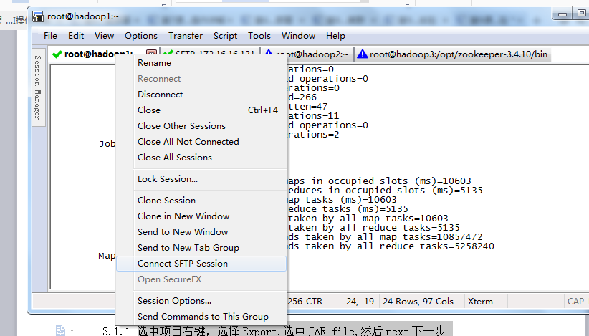

2.1.2将jar直接拖到sftp上
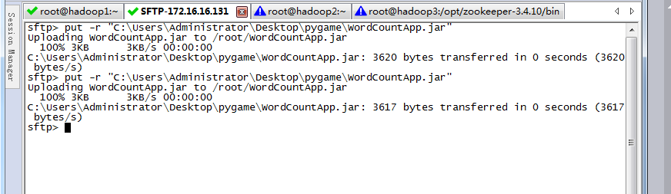

2.1.3 然后执行下面命令
[root@hadoop1]# hadoop jar WordCountApp.jar

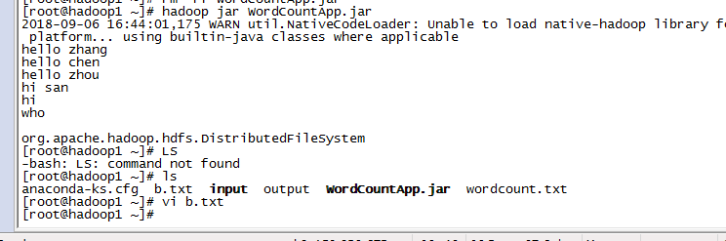

2.1.4 执行读取成功，查看文件数据
[root@hadoop1]# vi b.txt
读取HDFS数据操作成功

2.1.5 执行写入成功，查看文件数据
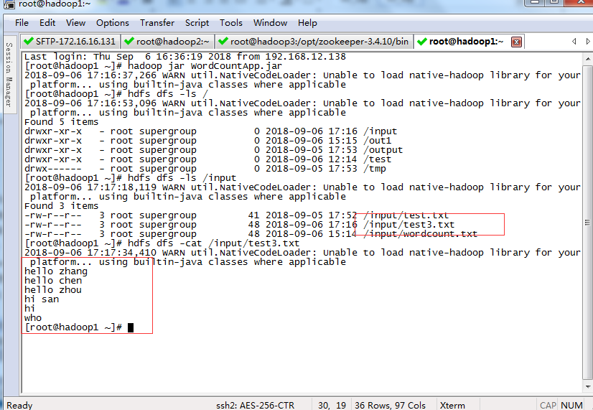
写入HDFS数据操作成功

至此，本节实验结束！

